**TEAM ID: PNT2022TMID08472**

**TEAM LEADER: MARIA MANOJ KUTTOMPARAMBIL**

**TEAM MEMBER 1:K.KAVYA**

**TEAM MEMBER 2:A.BHUVANESHWARI**

**TEAM MEMBER 3:A.AGASHIYA**

Create Node-RED Service

To create a web application create a Node-RED service.

Step 1: Go to IBM cloud and Click the Catalog and go to Node red :

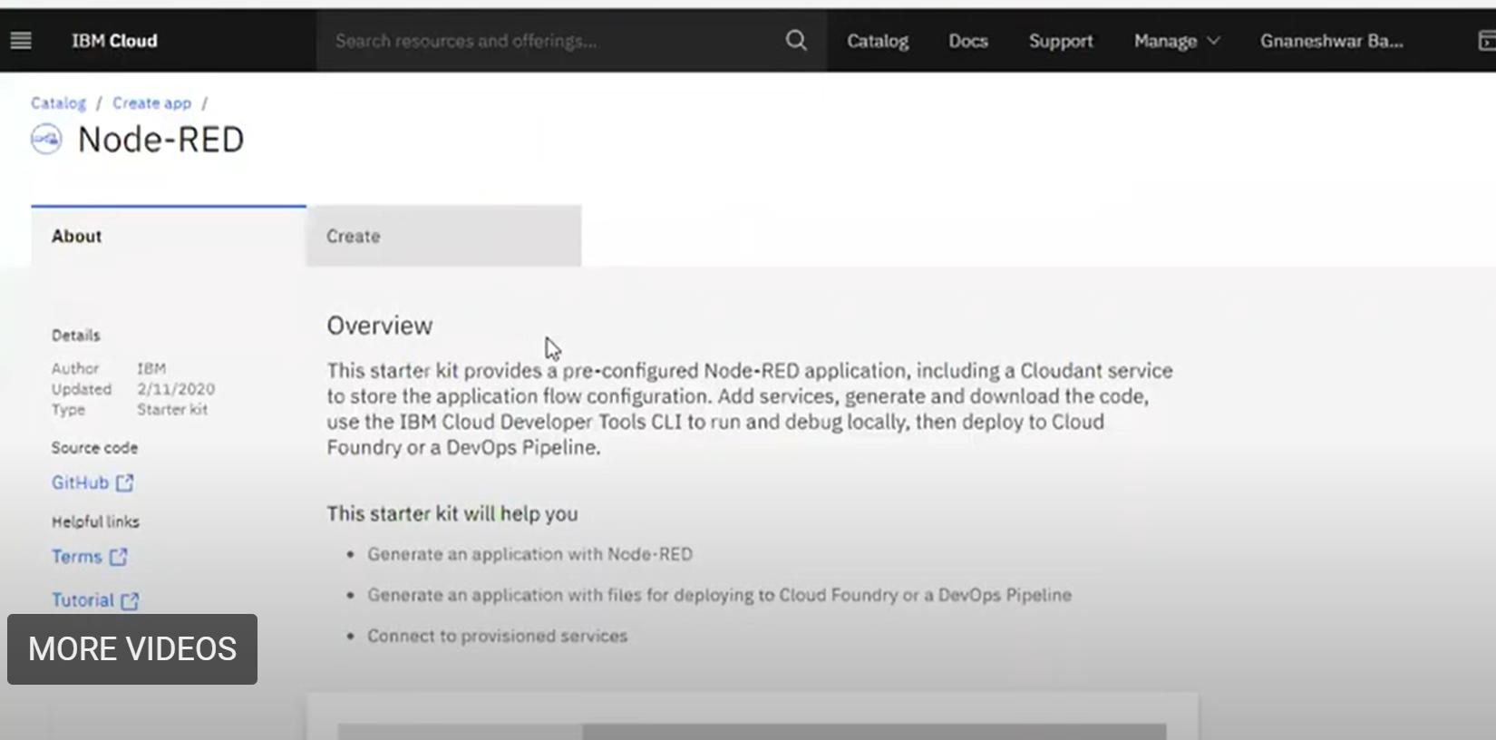

Step 2: Create and Choose the Pricing plan and Deploy your app:

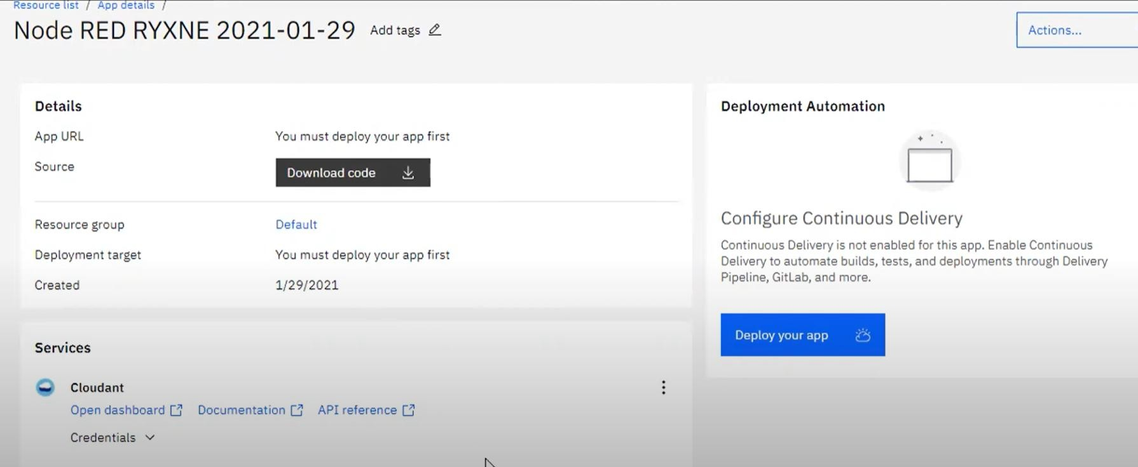

Step 3: Choose API key and fill the details and press next:

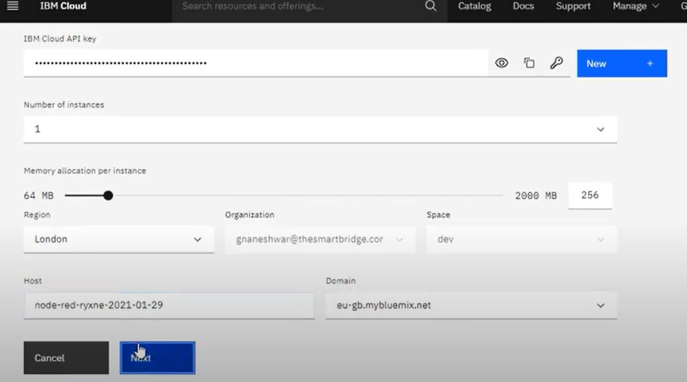

Step 4:After Successfully completed ,the refresh the page and click the App URL:

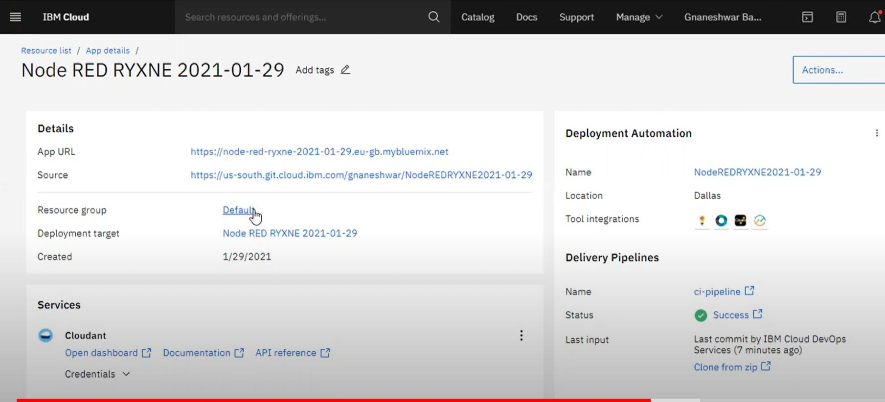

Step 5:After click next and click not recommended for username:

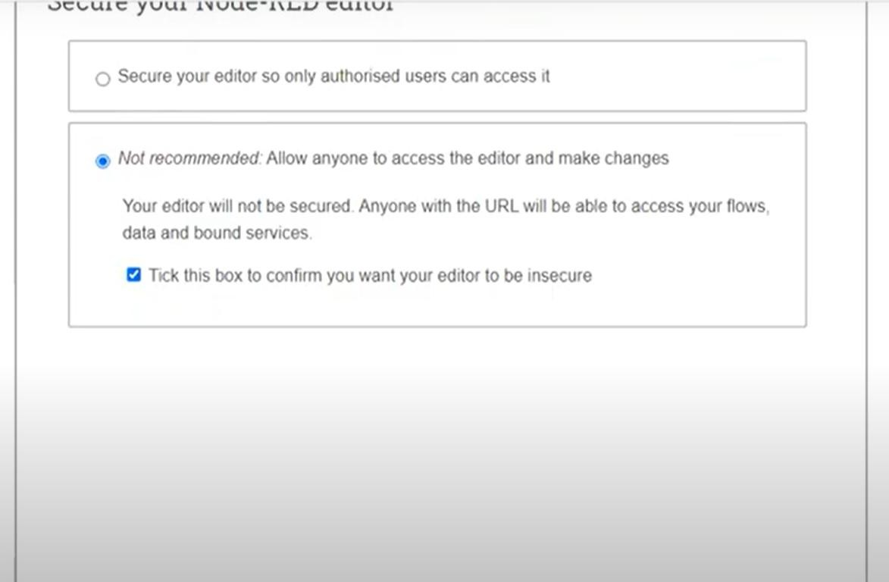

Step 6:Click Go to Node-Red and start your work:

